Impact of South Carolina’s Temporary Assistance to Needy Families (TANF) Program on Earnings of New Entrants
Before and During the Recent Economic Recession

Qiduan Liu, Cynthia Flynn
Center for Child and Family Studies, College of Social Work, University of South Carolina

Abstract
This study employs multiple-group, piecewise, latent curve models to assess the impact of South Carolina’s Temporary Assistance for Needy Families (TANF) program on the longitudinal earnings of three cohorts of approved applicants that entered the study before the recent recession, at the beginning of the recession, and at the height of the recession. Applicants screened out by intake staff as ineligible and then statistically matched to approved applicants by pre-intervention earning history, demographic characteristics and local economic conditions served as the comparison group. The findings show the state’s TANF work support program had a positive impact on the earning trajectories of TANF clients when the economy was normal. The effect became weaker during the state’s period of rising unemployment, and disappeared during the worst economic time in decades.

Background
- South Carolina’s TANF program, FI, promoted employment among welfare recipients by providing work support services, including job search and job skills training.
- Most evaluations of the effectiveness of TANF were conducted during a booming economy, described the well-being of one group of welfare recipients over one or two time points, or employed inappropriate analytical techniques.
- With the availability of longitudinal wage and background information, latent growth curve modeling provides a powerful method for the evaluation of long-term effects of intervention.

Purpose of the Study
- To assess the impact of the FI program on post-intervention wage trajectories of program participants.
- To find out whether FI impact diminished or vanished during a recession.
Method
- Sample consisted of three cohorts of single parents who applied to FI before, at the early stage of, and at the height of the 2008-2009 recession.
- Treatment and Control groups within each cohort group were selected from the approved and ineligible applicants, and matched on pre-intervention wage history, county unemployment rates, and a set of demographic factors.
- Repeated measure of wage data, both before and after intake, were obtained for each member in the treatment and control group.
- A multiple-group, piecewise, latent curve model was employed to address the research questions.
Graphical analysis
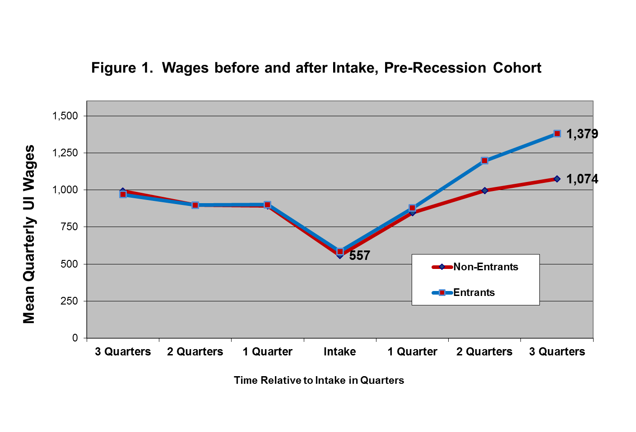

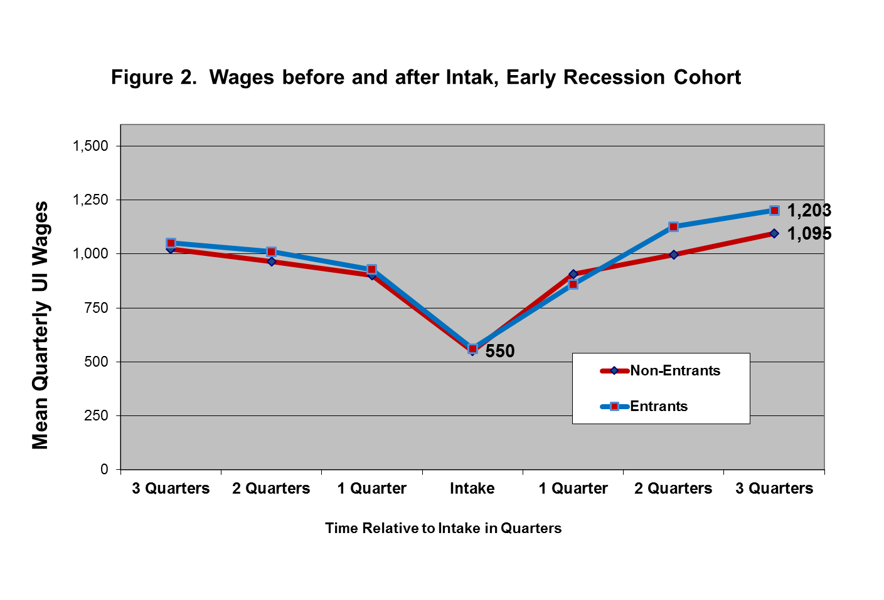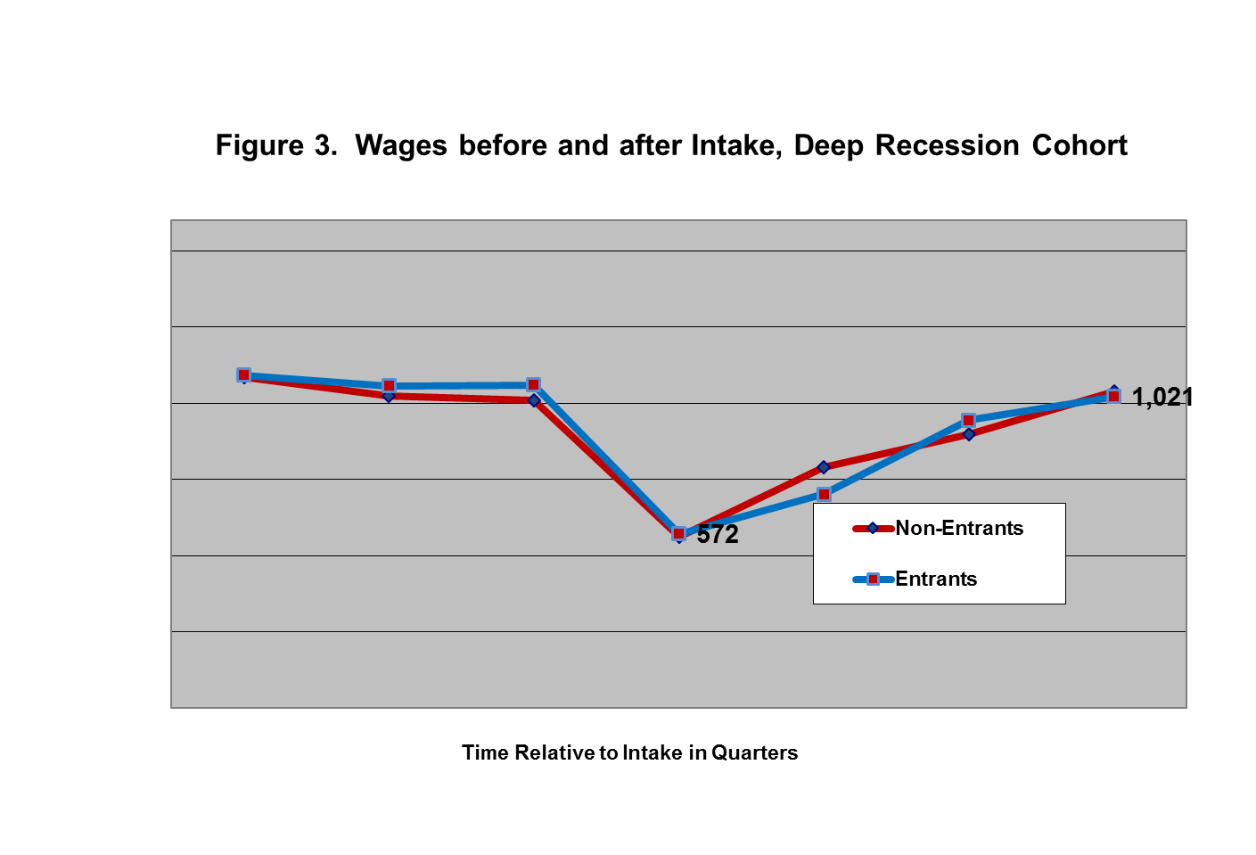

Baseline Model
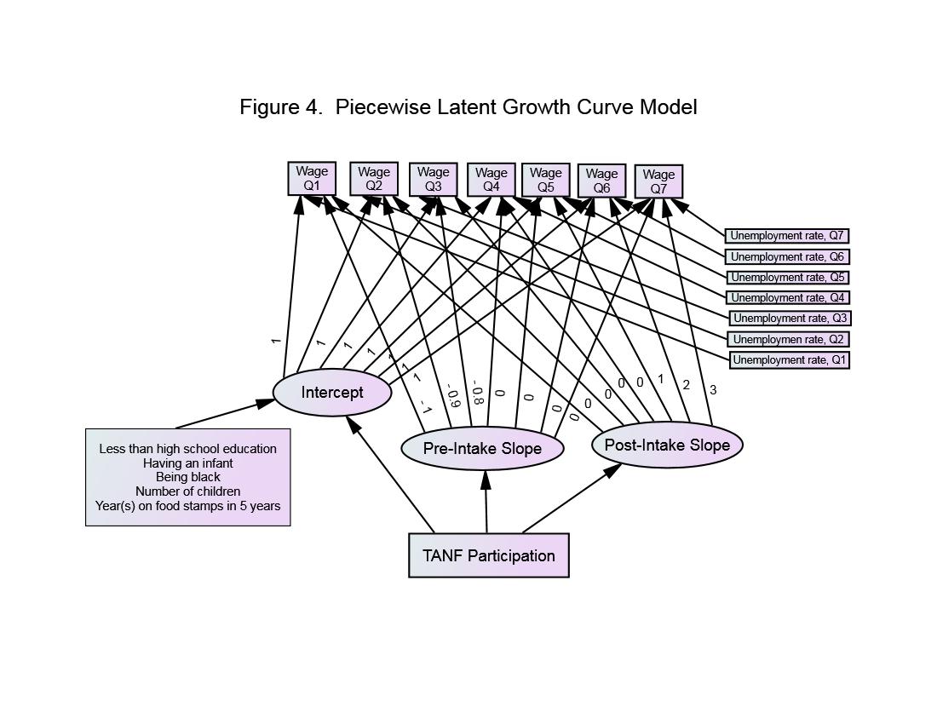
Modeling Steps

- Determine if the baseline model fit data for each of the three cohort groups.
- Fit the baseline model simultaneously for the three cohorts, allowing all parameters to be freely estimated.
- Put equality constraints on the parameter representing FI impact across the cohort groups, and use chi-square difference test to decide how well the constrained model fit compared with the unconstrained model.
Results
- Baseline model fits well for the three cohorts according to major fit indices (RMSEA is 0.043, 0.036, 0.038).
- Wage increased by close to $300 per quarter after intake for both treatment and control.
- Additional increases per quarter for the treatment group was $93.8 before recession, $36.3 at the early stage of recession, and $0.2 at the height of recession. These FI impact estimates were significantly different across cohorts.
Table 1. Results from Fitting the Baseline Model Separately to Cohort Groups
Effects | 2007 Cohort N=1,882 |  |  | 2008 Cohort N=2,274 |  |  | 2009 Cohort N=2,672
Growth Parameters and Effect of Participation in FI | Coefficient | SE | t Value | Coefficient | SE | t Value | Coefficient | SE | t Value
Intercept (α) | 380.7 | 95.8 | 3.97 | 622.6 | 89.0 | 6.99 | 606.6 | 91.1 | 6.66
FI Participation on Intercept | 11.7 | 42.1 | 0.27 | 11.1 | 42.3 | 0.26 | -6.2 | 38.9 | -0.16
Pre-Intake Slope (β₁) | -621.0 | 115.5 | -5.37 | -511.8 | 102.3 | -4.99 | -744.7 | 112.9 | -6.60
FI-Participation on Pre-Intake Slope | 32.3 | 56.5 | 0.57 | -30.4 | 56.7 | -0.53 | -41.3 | 55.4 | -0.75
Post-Intake Slope (β₂) | 291.8 | 50.4 | 5.78 | 305.4 | 48.7 | 6.26 | 326.9 | 47.9 | 6.83
FI-Participation on Post-Intake Slope | 93.8 | 26.7 | 3.50 | 36.3 | 24.8 | 1.46 | 0.2 | 21.0 | 0.01
Time-Varying Unemployment Rate $(ω_{t})$on Wage_{t}
Unemployment Rate₁ on Wage₁ | -18.3 | 19.3 | -0.94 | -42.0 | 18.9 | -2.21 | -61.7 | 19.7 | -3.13
Unemployment Rate₂ on Wage₂ | -21.5 | 17.2 | -1.25 | -39.8 | 16.3 | -2.44 | -45.7 | 14.6 | -3.12
Unemployment Rate₃ on Wage₃ | -14.9 | 17.0 | -0.88 | -43.7 | 15.6 | -2.79 | -33.6 | 12.0 | -2.81
Unemployment Rate₄ on Wage₄ | 10.4 | 11.8 | 0.88 | -32.2 | 11.4 | -2.82 | -12.3 | 6.5 | -1.88
Unemployment Rate₅ on Wage₅ | 1.4 | 14.3 | 0.10 | -33.7 | 12.5 | -2.70 | -25.5 | 7.1 | -3.61
Unemployment Rate₆ on Wage₆ | -15.8 | 17.9 | -0.88 | -45.8 | 13.4 | -3.40 | -37.0 | 9.0 | -4.11
Unemployment Rate₇ on Wage₇ | -49.7 | 24.5 | -2.02 | -64.9 | 15.8 | -4.10 | -54.7 | 12.1 | -4.54
Time-Invariate Variables on Intercept (α)
Less than High School | -268.6 | 43.7 | -6.14 | -223.3 | 44.2 | -5.04 | -248.9 | 41.1 | -6.05
Having an Infant | 67.1 | 50.5 | 1.32 | 51.5 | 49.5 | 1.04 | -17.2 | 47.5 | -0.36
Black | 227.5 | 43.8 | 5.20 | 265.7 | 44.3 | 5.98 | 237.2 | 40.5 | 5.85
Number of Children | -18.0 | 21.5 | -0.84 | -21.5 | 20.9 | -1.03 | -1 | 18.7 | -0.05
Years on SNAP | 39.0 | 9.8 | 3.97 | 26.5 | 9.6 | 2.76 | 22.2 | 9.2 | 2.40

Contribution
- We employed a number of design techniques that effectively enhanced the strengths of the study.
- We demonstrated the usefulness of latent growth curve modeling in real-data analysis of social service research questions.
For more information, email qiduanl@mailbox.sc.edu, cynthiaf@mailbox.sc.edu

